1. 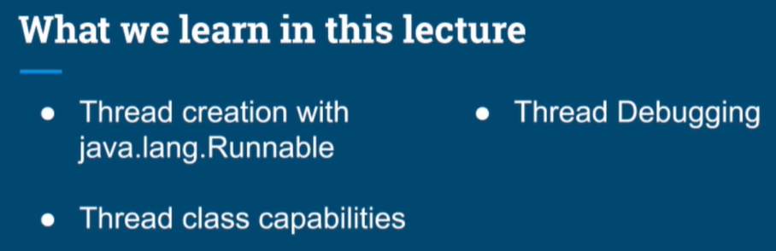
2. 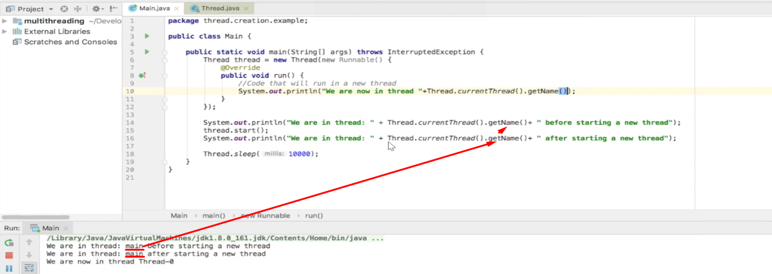
3. 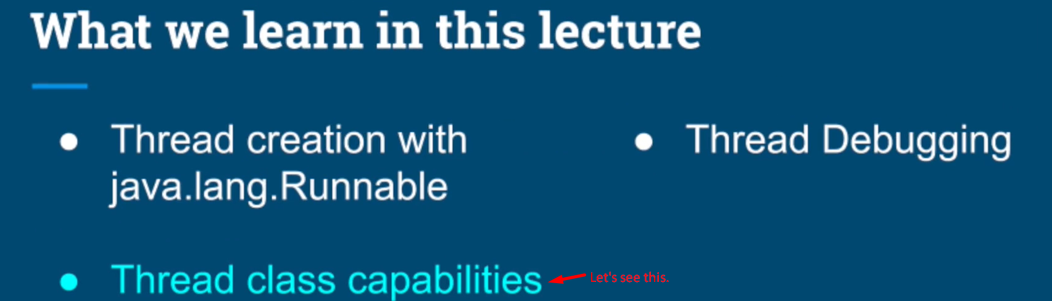
4. 
5. 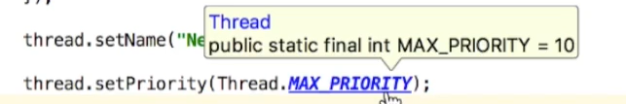
6. 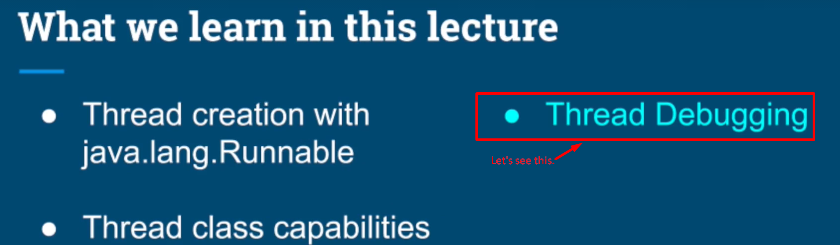
7. The instructor tried debugging in IntelliJ.
8. 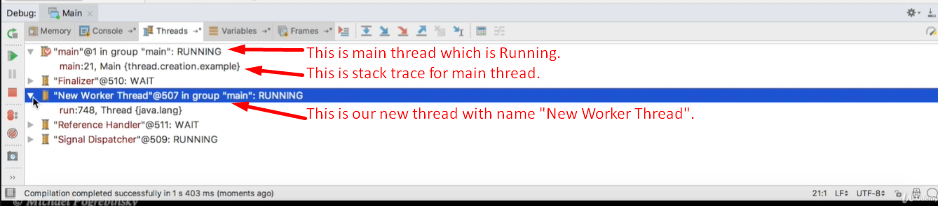
9. Let’s see one more capability to handle uncaught exception from a thread.
10. 